The distance is never too far, if the destiny is clear  Our mission is to bridge the gap between the art of business management and the science of information technologies  We do that by methodically asking questions, listening, gathering data (evidence and metrics), and working with you and your stakeholders to develop tailored IT strategies with customized solutions designed to help you achieve your specific goals. |  | Contact us today for a no-obligation, no-cost introductory consultation. mantos.com Email Info@mantos.com  Mantos IT Consulting, Inc. Albuquerque, NM 87106-1419 Tel (505) 328 - 6791 |  | Mantos IT Consulting, Inc.  - TechAlign™  Align Your Technology with Your Vision:  Strategic IT Consulting for Businesses, Public Entities, and Non-Profits

Why Conduct a TechAlign™ Analysis?  With TechAlign™, you will:      Align IT with Your Mission: Ensure your technology supports your long-term goals.    Spend Less on IT: Avoid overspending by optimizing IT budgets.    Improve Efficiency: Integrated solutions lead to seamless operations.    Boost Productivity: Enable your team to work smarter and faster.  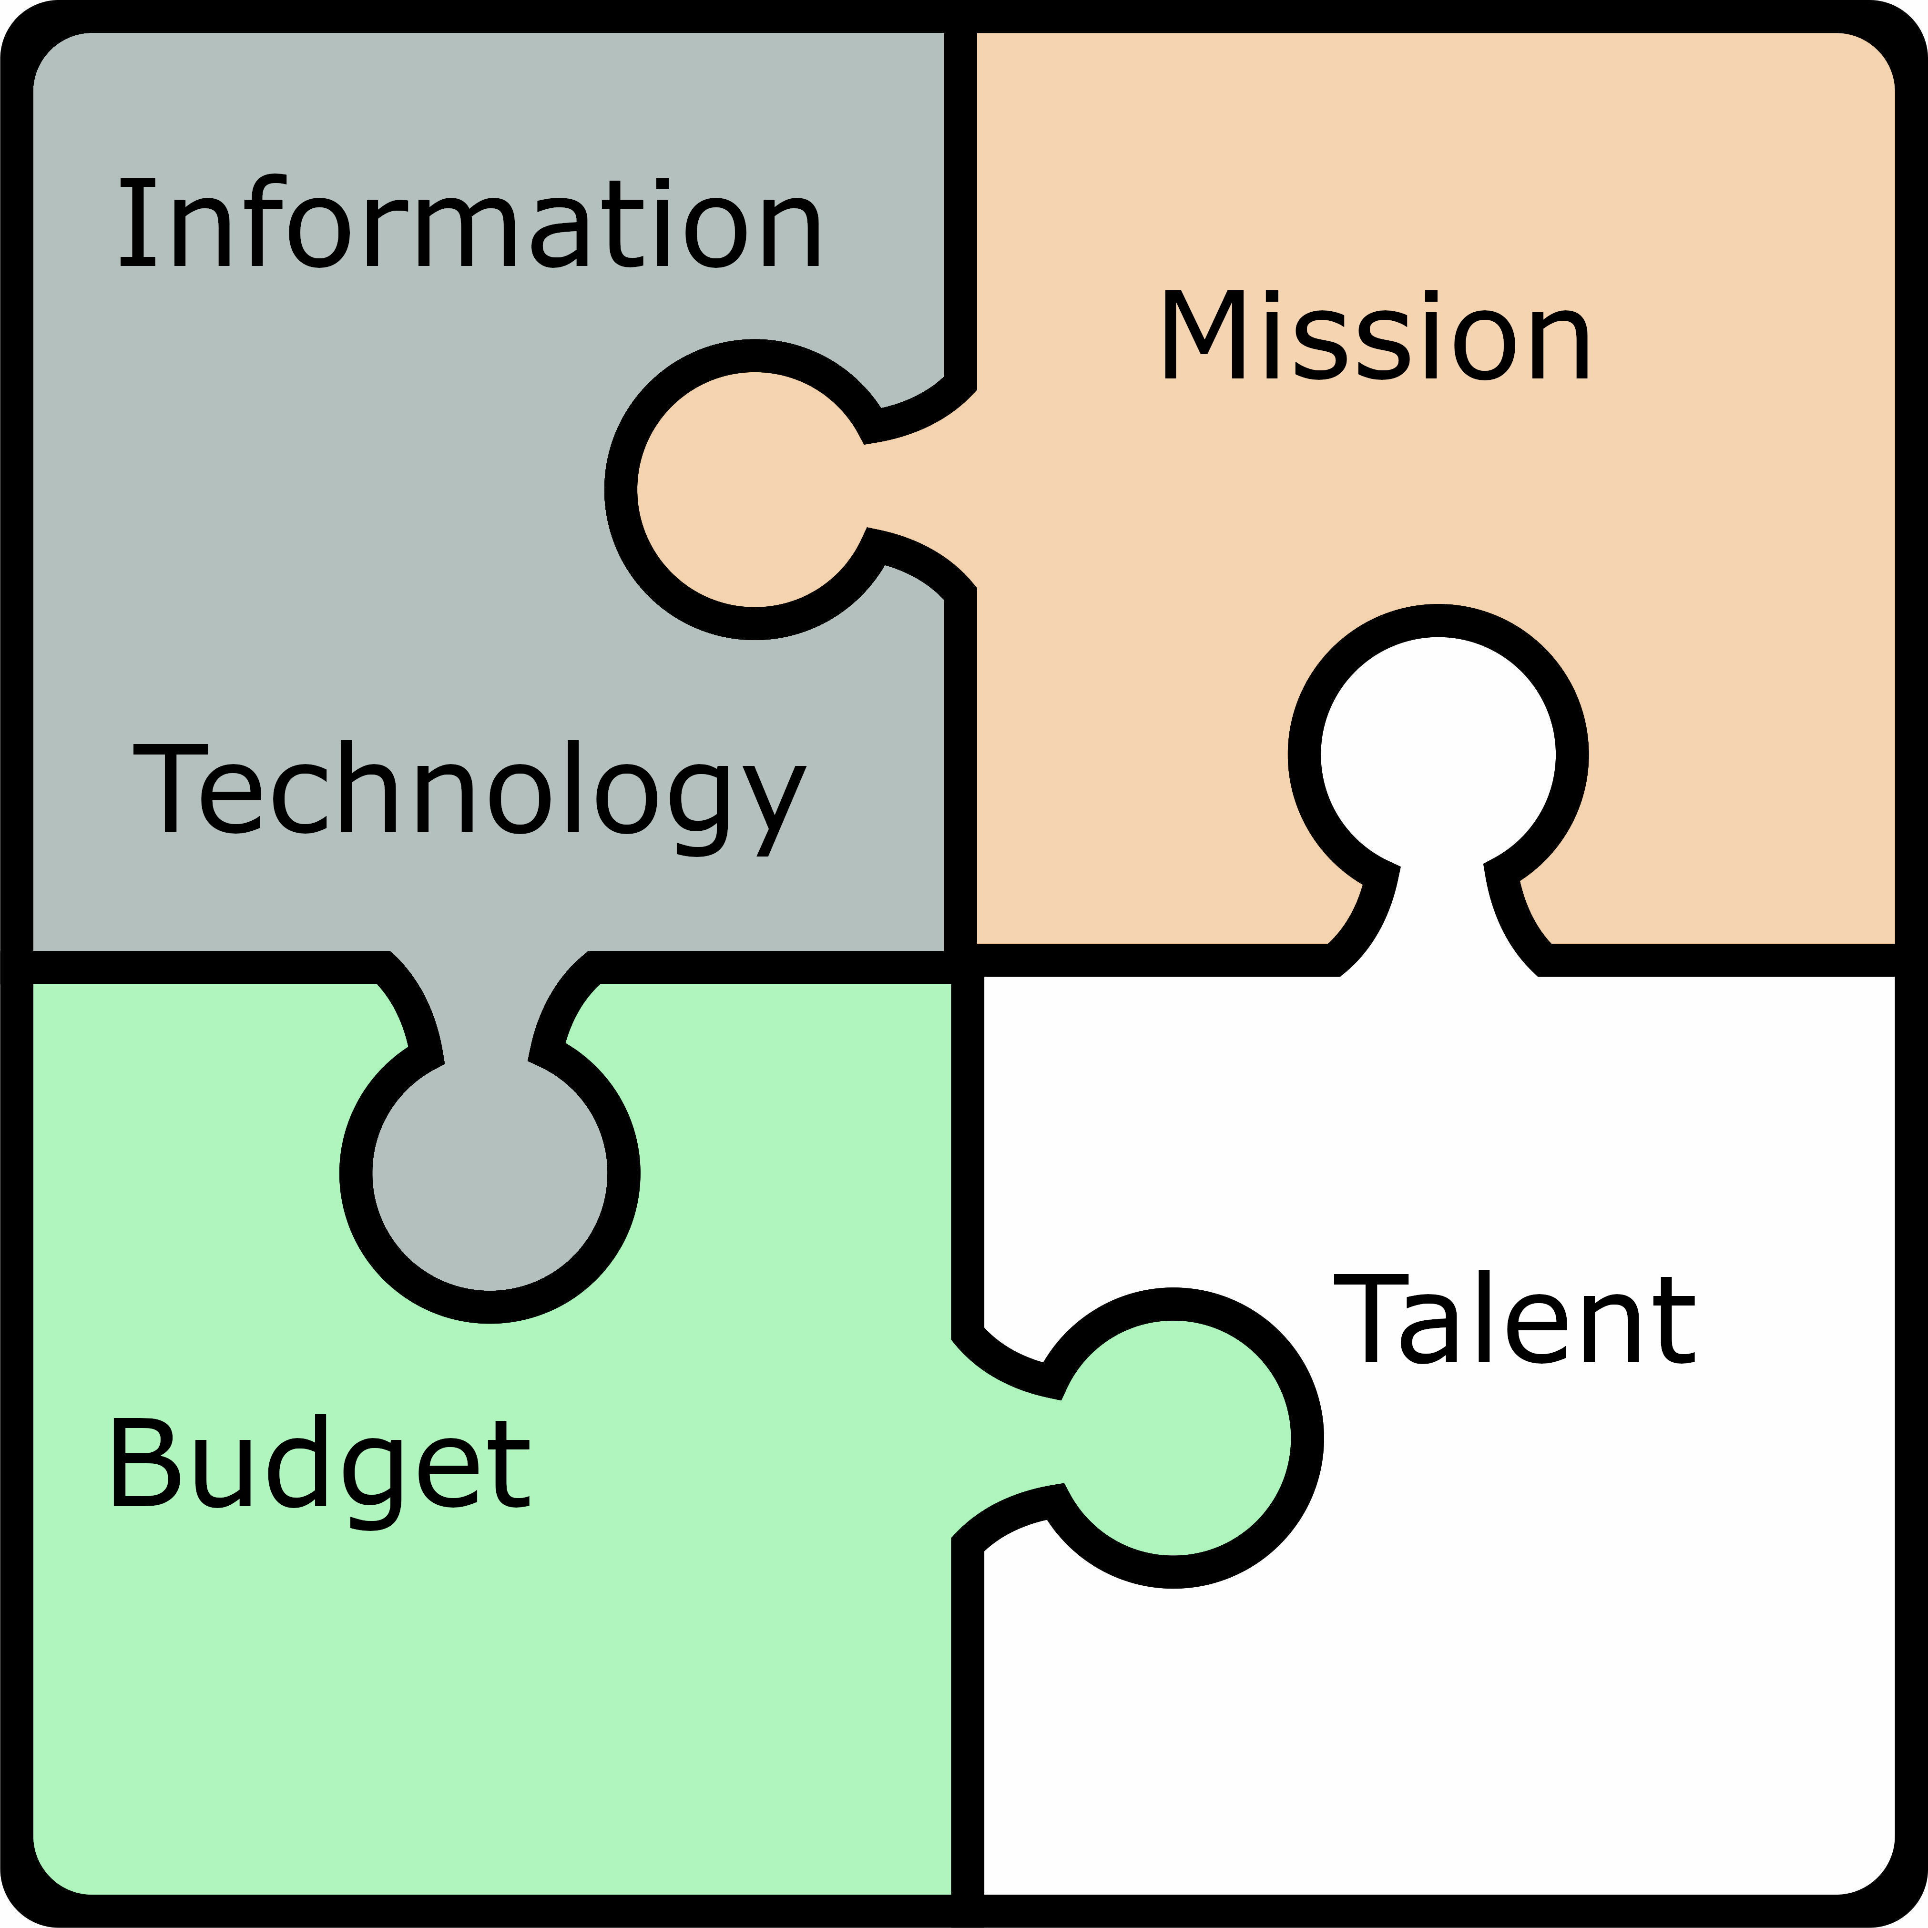  Enhance Security: Protect your organization from cyber threats and ensure compliance.  Call for a free consultation,  505-328-6791 |  | We know the right questions to ask to help you find the best answers to get you where you want to be.  How Does TechAlign™ Work?  We follow a structured seven-step process:  - Business Discovery  - IT Assessment  - Business Continuity and Disaster Recovery  - SWOT Analysis  - Gap Analysis  - Strategy Formulation  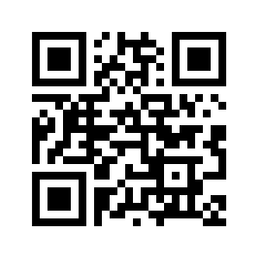  - Creation and Delivery of TechAlign™ Process Deliverables  For more information, go to mantos.com/techalign  TechAlign™ Tri-Fold Brochure Rev: 09-Oct-2024 |  | Who Can Benefit from TechAlign™?  Businesses: looking to optimize technology investments and boost growth.  Public Entities: seeking efficient IT solutions to support critical services.  Non-Profits: aiming to maximize impact through smarter technology use.  Industries Served    Virtually EVERY organization MUST use IT in today’s world. Our customers include:    A small not-for-profit assisting Native Americans in securing financing for higher level education  The world’s largest semiconductor manufacturer  Law Firms specializing in personal injury, medical malpractice, and business law    Medical Practices, including the largest provider in New Mexico as well as smaller specialty practices  State Government and Agencies

